Listed below are multiple recommendations for increasing physical security of equipment. The items in red are most effective and least expensive, except for #4 card swipe which can be expensive, but is very effective for deterring and identifying thefts:

- Consider rekeying areas to ensure legacies lost keys are not being misused (good choice for a limited number of areas and keys).
- Etch the equipment to lower the value for resale.
- Store equipment inside secure file cabinets or cupboards (Contact Public Safety for additional information).
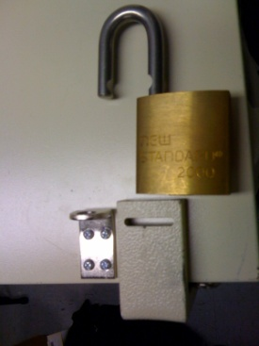
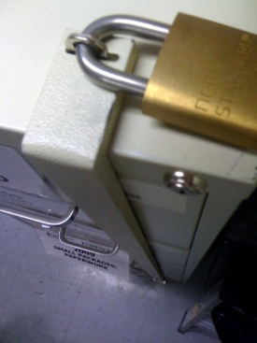
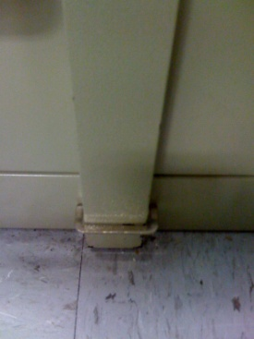
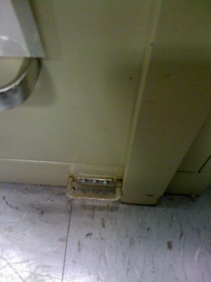

- Replace key locks with card swipe. This eliminates key issue problems and provides for logging of entry and immediate deactivation of access for separated employees. Consider switching your secured areas, one per year, over to card swipe. It may be more cost effective and over time the price should decline.
- If you have a card swipe installed, investigate having an alarm if the door is left ajar.
- To lower the number of keys issued and lost (or not turned in), consider a lock box where each user swipes their SDSU ID card to check out a key that is pre-authorized for the user to check out. Have the system programmed to alert when a key has not been returned within 24 hours.
- During staff or faculty meetings, explain the minimal value of locked doors and the importance of closing locked doors and the need to further secure valuable equipment inside.
- Divide up the storage of the equipment to lower the possibility that thieves can access all the equipment at once or to better limit authorized access to the equipment (i.e. students from once class can only access their equipment and not equipment used by other classes).
- Windows should be locked, with blinds closed to prevent viewing interior. Grow thorny shrubs/bushes outside the window to deter access.
- If multiple entry points exist, consider sealing unnecessary doors, to create more secure access (i.e. force thieves to enter/exit through a door that is card swiped) or to increase the probability that someone will see the theft (force thieves to enter/exit through a door that is inside a suite of offices).
- If no custodial services needed, see if different key can be issued for access.
- If possible, bolt equipment to desks (with bolts inaccessible) to deter casual thefts. Usually this requires roughing up the equipment and acts as a type of etching. Even if you bolt a laptop to a moving cart you lower the risk of theft as thieves have to take the whole cart in a crime or opportunity.
- Inventory equipment at least weekly to help identify when it was lost or stolen. Make sure the inventory includes a serial number for all equipment, regardless of value or whether it is tagged for campus inventory. Law enforcement needs the serial number to identify recovered equipment and charge individuals responsible for thefts.
- Motion detection cameras. Remember, this works to identify internal thefts. It may not help to identify a stranger.
- Install Lojack to help track a stolen computer. It is activated by law enforcement, after a police case is opened. Three year software download is $89, and $39 per year: http://www.absolute.com/products/lojackforlaptops . Many computing companies are a partner with Lojack and have the product built in: Dell@absolute.com, HP@absolute.com, Toshiba@absolute.com, and others are listed under OEM on their website.
- For computers, ensure they are always connected to the network while on campus, and contact John Denune to investigate the possibility of revising the DHCP leases to renew every 30-60 minutes so law enforcement can better pinpoint loss of connection to the network.
- Install Sonic Alarms on equipment to alert when the equipment is being stolen. Closest vendor is:

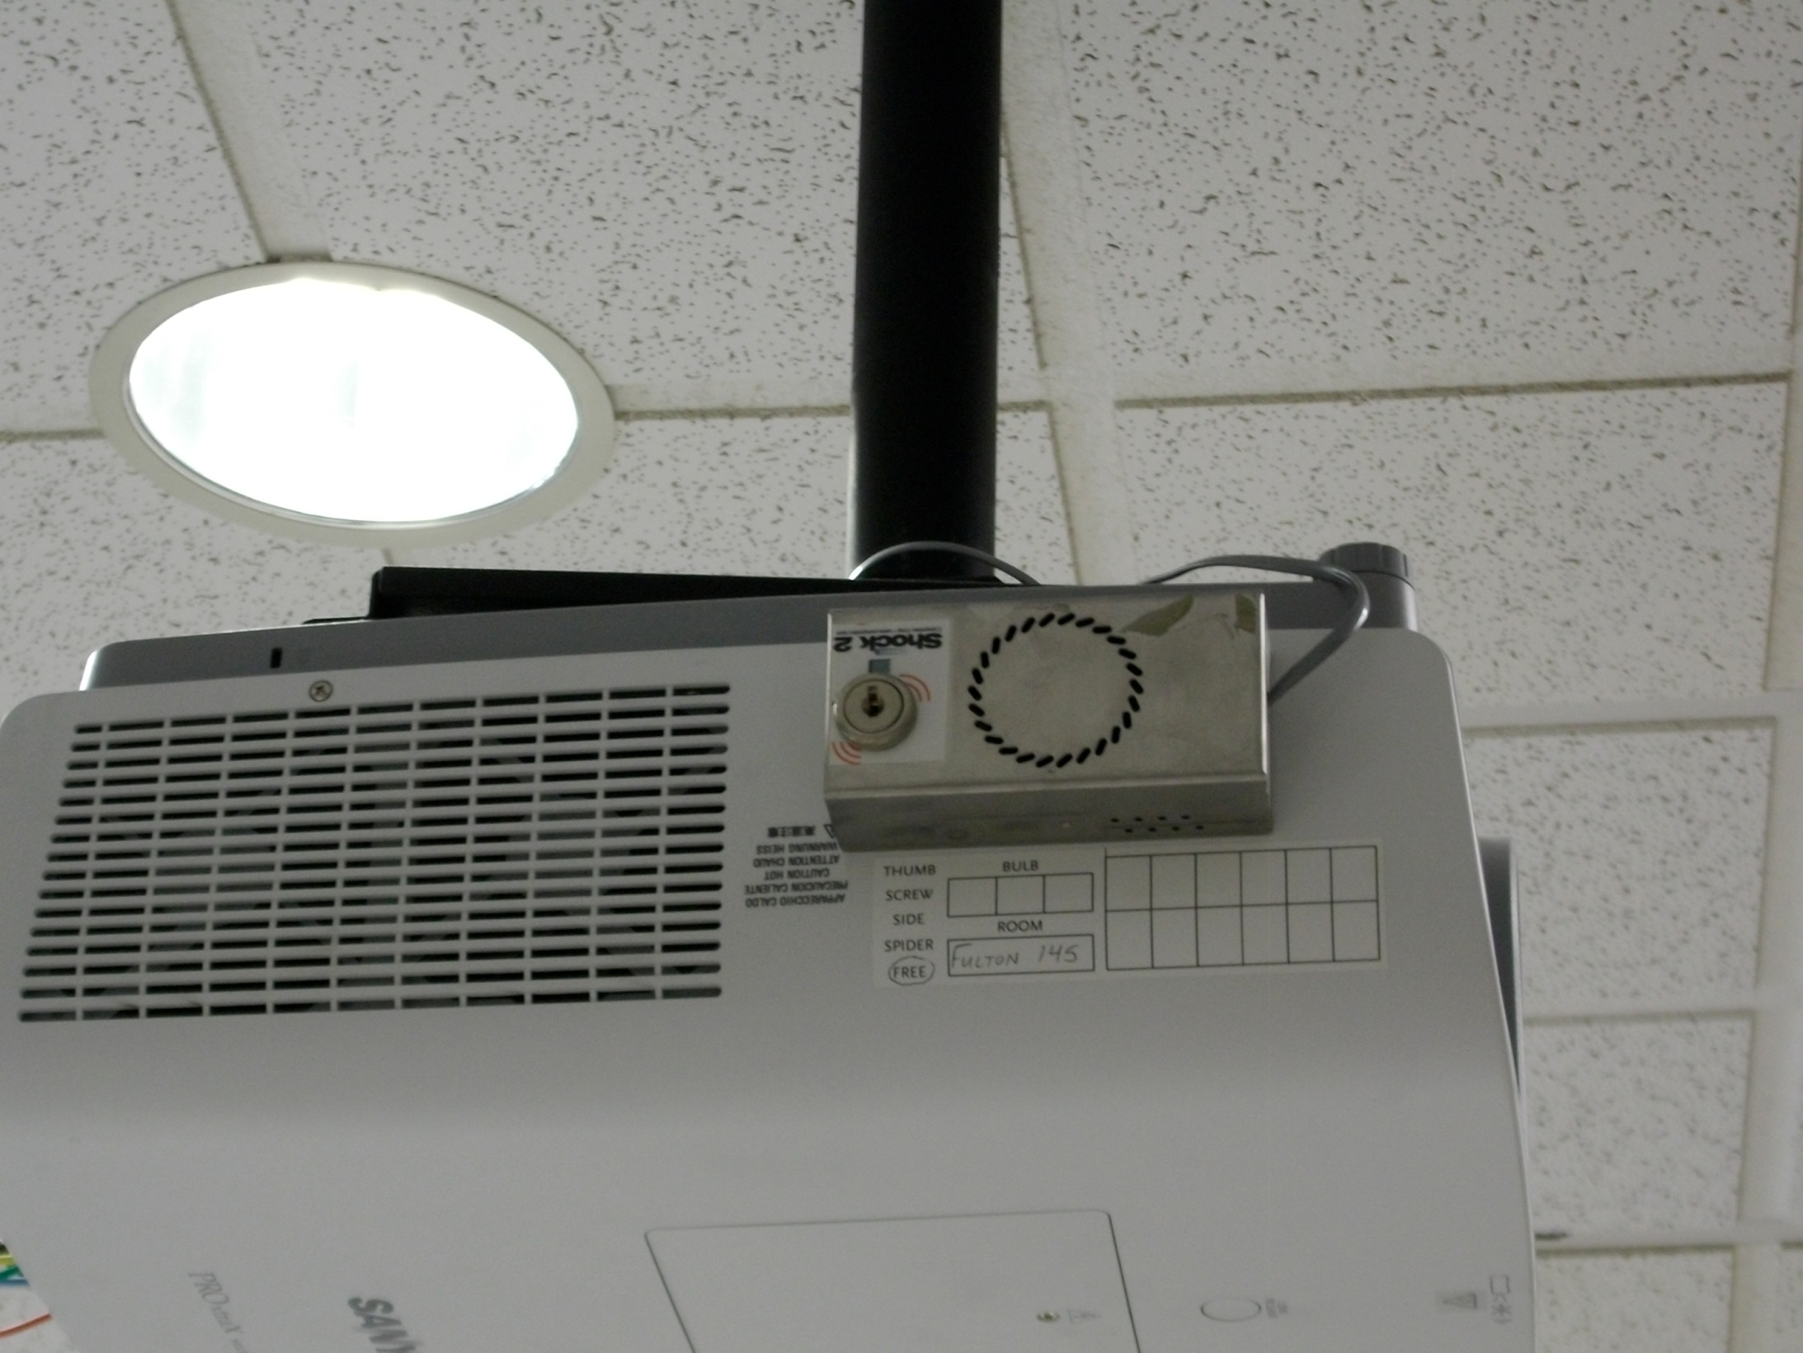
D&D Security Resources, Inc.
Other end of assembly affixed
to ceiling mount (Not visible)
Corporate Support Center
When cord cut, sounds alarm
1630 So. Sunkist Street, Suite M
Anaheim, CA 9280
Tel: 800 453 4195
Fax: 925 299 1758

Sonic shock alarm affixed to projector

For areas with many physical security issues, revisit this list each semester or quarter to continue to increase security according to budget allowance and change in operations. For example, if installing card swipe is too expensive for all storage areas, install one card swipe each semester in order of highest risk area for personnel or equipment. Over time, you will increase the physical security and lower the risk to equipment and personnel.

